**ACKNOWLEDGEMENT**

First of all, I would like to be grateful to the Almighty Allah for giving me the effort to work on this project. Special thank goes to my honorable Supervisor Mr Ragib Hassan Sir, Lecturer, Computer Science and Engineering, University of Liberal Arts Bangladesh for his constant support and motivation.

I also convey my thanks to Dr. Abul Kalam Al Azad, PhD Associate Professor & Acting Head, Department of Computer Science and Engineering, for this kind help to finish my project and also to other faculty members of Computer Science and Engineering Department of University of Liberal Arts Bangladesh.

Next, I convey thanks and acknowledge my university, University of Liberal Arts Bangladesh. I also thank our beloved classmates who appreciated my work.

Last but not least I thank my respectable parents and siblings for their unconditional support and unconditional love; it would not be possible to complete my project without them.

**Abstract**

The people of Bangladesh are very fond of traveling, as well as the people of the country have a weakness for the famous food of different regions. If we talk about people who are thirsty for travel, Bandarban is one of the most popular travel destinations in Bangladesh. Where millions of people flock every year for leisure. There are many places of interest in Bandarban. Tickets are available for most visits. Collecting so many tickets from visitors sometimes becomes extremely difficult for the authorities. Lack of adequate manpower, lack of arrangement of many ticket counters, which is an embarrassing for tourists. Moreover, those who want to stay there need hotels for overnight stays. It was seen that after going to the hotel many times, it was seen that the room was not empty. I think it is very embarrassing for the tourists. People in different parts of Bangladesh have a weakness for the food produced in the Bandarban hills. Those who travel there collect it when they arrive. But for those who want to collect these foods without traveling, it becomes difficult for them to collect from different sources. Why Bandarban will lag behind in the whole of Bangladesh where information technology revolution is taking place. In this context, development of an application called "Hello Bandarban" and it is taken as my undergraduate final year project. From where any user of this application can book tickets for places of interest before going to Bandarban, as well as hotel room if the user wants to stay there. Above all, users of this application can order crops produced in the hills of Bandarban from any part of Bangladesh. Not only will this application be useful for users or tourists, I think all the hotel owners in Bandarban as well as the owners of places of interest and those who are producing crops in the hills will be able to reach all the people of Bangladesh through this application. At the same time, I think this industrial sector of Bandarban will go one step further.

**Table of Contents**

**Chapter: 1 Introduction**

1.1 Introduction

1.2 Motivation

1.3 Objective

1.4 Expected Outcome

1.5 Project Management and Finance

1.5 Project Report Layout

**Chapter 2: Background**

2.1 Preliminaries

2.2 Related Work

2.3 Comparative Analysis

2.4 Scope of Problem

2.5 Challenges

**Chapter 3: Requirement Specification**

3.1 Business Process Model

3.2 Requirement Collection and Analysis

3.3 Use Case Modeling and Description

3.4 Logical Data Model

3.5 Design Requirements

**Chapter 4: Design Specification**

4.1 Font-end Design

4.2 Back-end Design

4.3 Interaction Design and User Experience

4.4 Implementation Requirements

**Chapter 5: Implementation and Result**

5.1 Implementation of Database

5.2 Implementation of Font-end Design

5.3 Testing Implementation

5.4 Test Result

**Chapter 6: Impact on Society, Environment, Sustainability**

6.1 Impact on Society

6.2 Impact on Environment

6.3 Ethical Aspects

6.4 Sustainability

**Chapter 7: Conclusion and Future Work**

7.1 Conclusion

7.2 Limitation

7.3 Scope of Future

**Reference**

**List of Figures**

1. Figure 3.1: Business Process Model

2. Figure 3.2: Waterfall Model

3. Figure 3.1: Use Case Diagram

4. Figure 3.4: Logical Data Model

5. Figure 4.1.1: Front-end design of home page.

6. Figure 5.1.1: Implementation of sql database.

7. Figure 5.2.1: Home Page

8. Figure 5.2.2: Hotel Room Page

9. Figure 5.2.3: Hotel Details Page

10. Figure 5.2.4: Tour Spot Home Page

11. Figure 5.2.5: Spot details page

12. Figure 5.2.6: Shop home page

13. Figure 5.2.7: Product Details

14. Figure 5.2.8: Dashboard page

15. Figure 5.2.9: Change Password page

16. Figure 5.2.10: Edit Profile page

17. Figure 5.2.11: Hotel booking list

18. Figure 5.2.12: Product booking list

19. Figure 5.2.13: Spot ticket booking list

20. Figure 5.2.14: product list

21. Figure 5.2.15: product booking request list

22. Figure 5.2.16: Spot list

23. Figure 5.2.17: Spot ticket booking request list

24. Figure 5.2.18: Hotel list

25. Figure 5.2.19: Hotel room booking request list

**Chapter: 1**

**Introduction**

* 1. **Introduction**

Hello Bandarban is a web-based program that manages hotel reservations, online store item reservations, and visit place ticket reservations. It was made to eliminate the problem of winning in the rehearsal manual framework. This solution is designed to eliminate and occasionally reduce the problems that this present framework is experiencing. Furthermore, this framework is developed for the organization's special need to do operations in a smooth and strong manner.

"Hello Bandarban," as seen above, can result in a system that is error-free, secure, reliable, and quick to administer. It might assist the customer in focusing on their various workouts rather of keeping track of their records. As a result, the organization can benefit.

**1.2 Motivation**

Bandarban is one of the major tourist spots in Bangladesh. It is at the top of the list of travel-loving people. People go here for leisure as well as for sightseeing. There are many places of interest in Bandarban. Generally, tickets are required to visit most of the places of interest. Visitors stand in line at the ticket counter to buy tickets and then they can visit. People who go for leisure have to go to hotels, motels, or resorts in person and book a room in person. As a result, there are long lines at the ticket counters of tourist centers of Bandarban. Tourists get access to tourist centers by standing in long lines and collecting tickets which is a waste of time and energy tourists. Tourists who travel to Bandarban for leisure stay at the hotel in person and often the hotel room is not available and that is very much painful for tourists. People working in the lines also have a lot of trouble while providing such tickets.

The zoom crops produced in Bandarban are very popular all over Bangladesh. Those who are tourists can collect it and bring it directly. But those who are not tourists will be able to use this system to order directly the crops produced in the hills of Bandarban.

If a tourist travels to Bandarban by booking hotel rooms and booking tickets to tourist centers through an online system, both energy and hassle can be avoided during the tourist's time. In that case, tourists will be able to travel to Bandarban with more ease. In addition, for the safety of tourists, the system will collect information about local public service organizations such as police fire service, etc. This will save a tourist's time and energy. This will also greatly reduce the tourists suffering. People are getting busier with the passage of time and in this business, if some time can be saved by using the blessing of technology is a great benefit.

The suffering of tourists and the person working to provide tickets will be greatly reduced if an online-based ticket system for tourist spots for Bandarban can be introduced. This System will improve the experiences for both tourists and the authorities. In this way, tourists will enjoy safe and smooth travel in Bandarban and those who are not tourists can collect hill crops produced in Bandarban from any part of Bangladesh through this system.

**1.3 Objective:**

The first and foremost reason behind of "Hello Bandarban" is to manage the booking system rooms of the hotel, products of the Online Shop, and ticket tour spots. It manages all the information about hotels, facilities, and Hotel Rooms. It also manages Tour spot tickets for the tourist's peoples and also gives the opportunity for users to book any kind of product from the online shop. The reason behind this this application is to build an application program to reduce the manual work of managing the Booking System. It tracks all the details about the Agent, Hotel, and Facility Shop Owner, Products and Tour Spot Ticket and Spot Information.

**Functionality of Hello Bandarban (Hotel Part):**

* Provide searching and filtering facilities based on various factor like hotel location, room type, room rent.
* Manage hotel rooms, booking request, booking management.
* Confirm and reject booking request.
* Showing all information on hotel room and booking details.
* Manage hotel owner information

**Functionality of Hello Bandarban (Shop Part):**

* Provide searching and filtering facilities based on various factor like product category, min price and maximum price.
* Manage shop products, product booking request, products booking management.
* Confirm and reject products booking request.
* Showing all information on product details and products booking details.
* Manage shop owner information

**Functionality of Hello Bandarban (Spot Ticket Part):**

* Provide searching and filtering facilities based on various factor like Spot name, location, time, date.
* Manage spot ticket, spot information, spot owner details, spot ticket booking and ticket booking request.
* Confirm and reject ticket booking request.
* Showing all information of spot details and spot booking details.
* Manage spot owner information

**1.4 Expected Outcome**

* User can successfully manage their accounts
* Hotel owner can add hotel room and manage room booking request.
* Searching hotel rooms and book them.
* Shop owner can add products and sell them.
* Shop owner can manage products and products booking.
* Searching specific product.
* Spot owner can add spot with ticket and manage spot ticket.
* Searching specific spot ticket and book them
* Manage spot booking request.
* 2 step user validation

**1.5 Project management and Finance**

3 motivations behind why finance is a fundamental piece of the project the executives

1. One of the principal motivations behind why finance is a fundamental piece of the project of the executives is on the grounds that each project should be arranged by a financial plan. Projects have targets and are arranged in like manner to meet these goals while adhering to a financial plan. The chief of a project ought to have planning abilities that permit them to really designate, figure, and appoint expenses for the various regions of a project, streamlining the spending.

2. One more fundamental piece of dealing with a project is the ability to have the option to survey the monetary suitability, monetary steadiness, and business productivity of a project through speculation evaluations throughout some stretch of time. This will permit a project administrator to estimate the outcome of a project and figure out what worth will be returned.

3. Project managers will likewise have to have abilities in overseeing income, benefit, and misfortune accounts as well as monetary records to have the option to screen and control costs during a project. It is not difficult to overspend on a careful spending plan, obliterating a project's timetable in the event that cash runs out. Observing spending is fundamental in guaranteeing a project can be done.

**1.6 Project Report Layout**

**Chapter 1** Here we will discuss about the project overview, the basic things about our project.

**Chapter 2** In this is section like related work, preliminaries technologies competitive study and challenges test for our project.

**Chapter 3** All the requirement analysis description and diagram like UML, Use Case Diagram, Logical Model Diagram will be added here.

**Chapter 4** Design specification part all the design requirement and database related data will be describing here.

**Chapter 5** In this part, all the implementation images and task will be discussing.

**Chapter 6** Here we will discuss about the social impact on society because of our project.

**Chapter 7** The conclusion part and other further process will be discussed here.

**Chapter: 2**

**Background**

**2.1 Preliminaries**

The essential objective of "Hello Bandarban" the board is to keep a consistent deluge of guests and visitors, who need to visit any place of interest and remain in an inn and furthermore need to book items on the web. As well as to advance the inn's broad scope of administrations and Spot ticket booking administrations and furthermore item reserving on the web. This application permits the lodging proprietor, place of interest proprietor, and the web-based retailer the capacity to work the whole framework from a solitary web-based interface, giving them more power and adaptability.

**2.2 Related Work**

There is a lot of website like ours but all these are not perfectly ok and not similar to our project. We can see many lacking in their sites. By utilizing those web site people aren't satisfied their expected demand. The current sites are offering the only individual support. Most of the site are developed by using android platform and they are charging fees for registration. We have study their work and see they most of the system are not secure and are not focusing on the user validation and they are showing all the data to the user that is a big mistake for their work. Some website is not user friendly at all and the donor are not real and they misbehave with the users. And one more thing most of the application have not any communication system between donor and the client. So solving all the issue we have built a web application that will work perfectly in mobile app and web version.

“The Travel Website" has been developed to override the problems prevailing in the practicing manual system. This software is supported to eliminate and in some cases reduce the hardships faced by this existing system. Moreover, this system is designed for the particular need of the company to carry out operations in a smooth and effective manner” [9]

“The application is reduced as much as possible to avoid errors while entering the data. It also provides error message while entering invalid data. No formal knowledge is needed for the user to use this system. Thus by this all it proves it is user-friendly. Travel Website, as described above, can lead to error free, secure, reliable and fast management system. It can assist the user to concentrate on their other activities rather to concentrate on the record keeping. Thus it will help organization in better utilization of resources” [9]. “The Hotel Booking System" has been developed to override the problems prevailing in the practicing manual system. This software is supported to eliminate and in some cases reduce the hardships faced by this existing system. Moreover, this system is designed for the particular need of the company to carry out operations in a smooth and effective manner. The application is reduced as much as possible to avoid errors while entering the data. It also provides error message while entering invalid data. No formal knowledge is needed for the user to use this system. Thus by this all it proves it is user-friendly. Hotel Booking System, as described above, can lead to error free, secure, reliable and fast management system. It can assist the user to concentrate on their other activities rather to concentrate on the record keeping. Thus it will help organization in better utilization of resources” [10].

**2.3 Comparative Analysis**

There are a lot of website and mobile app in the internet but all those application are not perfect and fully accessible for user. Behind all this they are not fully secure and well maintain. Another most important thing is that we are offering hotel room booking, online product booking, and tourist spot booking services. We have seen that these services are divided into part by part to other website but we are providing all these service together, that is the plus point for user and us. In [9], [10] we can see that there are 2 websites who are providing hotel management system and tour management but they are different and not user friendly. Adobe all these site our website is more user friendly and responsive more secure and protected.

**2.4 Scope of Problem**

It might assist with gathering ideal administration exhaustively. In an exceptionally brief time frame, the assortment will be self-evident, basic, and reasonable. It will assist an individual with knowing the administration of spent year impeccably and distinctively. It likewise helps in current all works comparatively with Travel sites, Spot Ticket booking, and Online item reserving. It will be additionally decreased the expense of gathering the administration and assortment technique will continue without a hitch.

Our undertaking focuses on Business process computerization, we have attempted to automate different cycles of Travel Websites.

* In a PC framework, the individual needs to fill the different structures and number of duplicates of the structures can be handily created at a time.
* In a PC framework, it isn't important to make the manifest yet we can straightforwardly print it, which saves our time.
* To help the staff in catching the work spent on their individual working regions.
* To use assets in a proficient way by expanding their efficiency through computerization.
* The framework produces sorts of data that can be utilized for different purposes.
* It fulfills the client prerequisite Be straightforward by the client and administrator
* Be not difficult to work Have a decent UI
* Be expandable Delivered on time affordable.

**2.5 Challenges**

Web administrations innovation is grown quickly as a functional means to coordinate heterogeneous frameworks and foster new applications. Our task effectively coordinates frameworks in lodging business chains together. Despite the fact that examination has enormously progressed around here, creating and keeping up with coordination frameworks in the lodging business stays a ton testing.

Our experience, first of all, involved that to send a worldwide, or to less scale, public wide inn reservation framework, there is a difficult experience ahead for the lodging business to get IT normalization. These days there are a few inn unions existing, yet these associations don't contact information trade principles between endeavors.

Furthermore, security is quite possibly the most significant and confounded challenge connected with our work. There are loads of examination papers on giving security answers for incorporation of heterogeneous PCs and assets spread across numerous spaces with the goal to give client administrations. We plan to get three essential targets. One is to keep the items private and honesty — that is to guarantee no one at any point alters or takes the information moved through open organizations. The other is to control admittance to web administrations. Prior to utilizing web administrations should pass the approval methodology.

**Chapter: 3**

**Requirement Specification**

**3.1 Business Process Modeling**

There are many software process model likely Business process modeling is a strategy used to record, plan and enhance business processes. Process models give a visual portrayal of the stages and stream of a process that is effectively perceived by specialized and non-specialized partners and assist associations with imparting official processes, further developing tasks and planning business process robotization projects. We choose Business process modeling because of its improving efficiency, transparency, process agility etc.

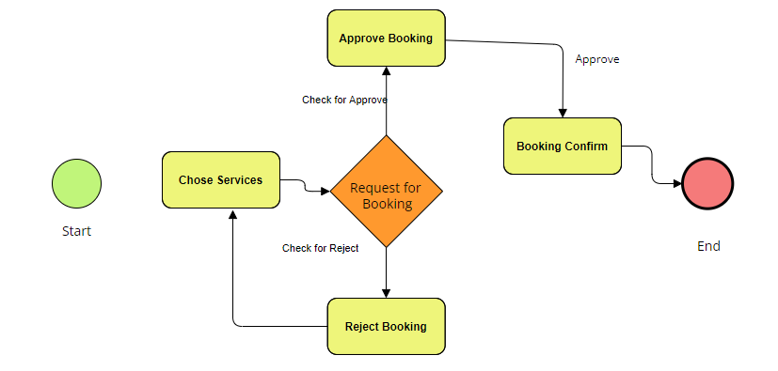

Figure 3.1: Business Process Model

**3.2 Requirement Collection and Analysis**

Requirement analysis refers to software interface with other system elements and also establishes some constraints. A programmer expands on essential necessities set up before prerequisite designing undertakings that permit a prerequisite investigation. If our project "Hello Bandarban” fails to achieve all-important requirements for structuring and further solution, then we have to face big trouble. So at this time our main responsibility should be collect all the requirements. We are following the software development model which is Waterfall Model.

According to our project requirement Waterfall Model will be suitable and easy to understand.

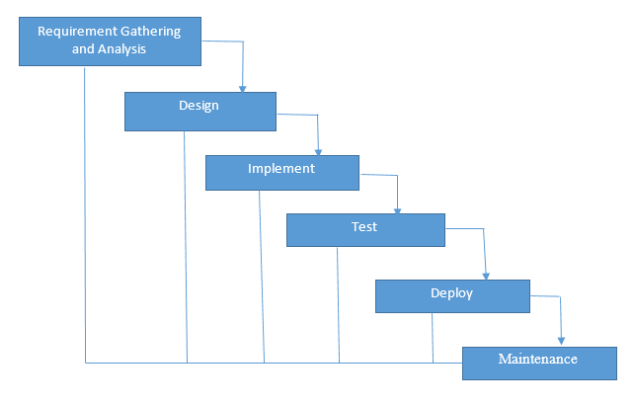

Figure 3.2: Waterfall Model

**3.3 Use case Modeling and Description**

* The programmer can communicate an inquiry model using the demonstrating documentation, which is represented by a set of textual and practical standards, similar to the tied together demonstrating language.
* five different views are handle by A UML system, each of which depicts the organization from a different standpoint. Each perspective is defined by a set of outlines, as shown in the diagram below.

The relationships between and among the actors and the use cases of “Hello Bandarban” an online booking system

* **Admin:** Use cases of Super Admin are managing users, manage spot, spot ticket, manage products and product booking, manage hotel rooms and rooms booking
* **Regular user:** Use cases of regular user are sear hotel room, book rooms, search room, search spot and book ticket, search product, book products.
* **Hotel owner:** Use cases of hotel owner are accepting and request room booking, add hotel rooms, manage rooms.
* **Shop Owner:** Use case of shop owner are adding product, accept booking request and cancel request.
* **Spot Owner:** Use case of spot owner are adding spot and ticket, accept ticket booking request, and cancel ticket.

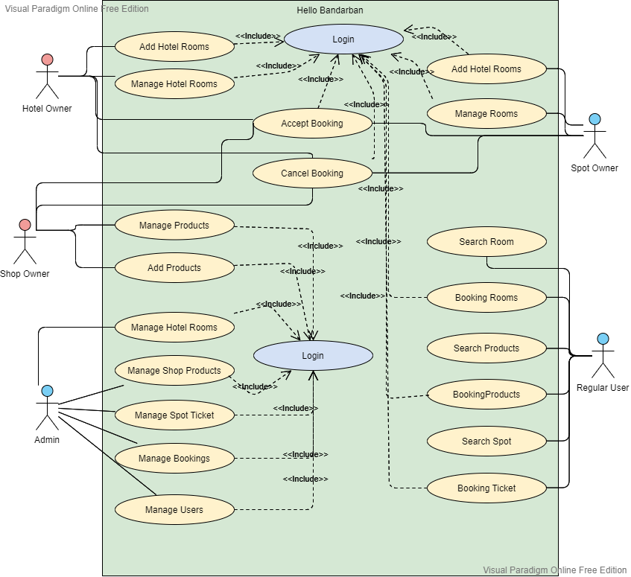

Figure 3.3 Use Case Diagram

So our project “Hello Bandarban” a web based online booking management system. In the diagram our project there are 4 types of user along with admin. Shop owner can add products to their shop and manage products. Regular user can search products and send booking request to shop owner. Shop owner can accept or reject product booking request. All the task performing both shop owner and regular user need to login. Hotel owner can also add hotel rooms and manage rooms. Here regular user can also search and book hotel rooms. Hotel owner can accept or reject room booking request. All the task performing both Hotel owner and Regular user need to login. Like that Spot owner can also add spot and spot ticket here and manage spot ticket. Regular user can search and send spot ticket booking request to the spot owner. Spot owner can accept or reject booking request. For both case spot owner and regular user need to be login. Admin have the full control over all kind of user. Admin can manage hotel owner and his hotel rooms, booking, shop owner and his products and booking, spot owner and his spot ticket and ticket booking request etc.

**3.4 Logical Data Model**

A Logical data model is a general depiction of the data- entities and relationships. It also shows attributes. Our system has some following set of Logical Data Model

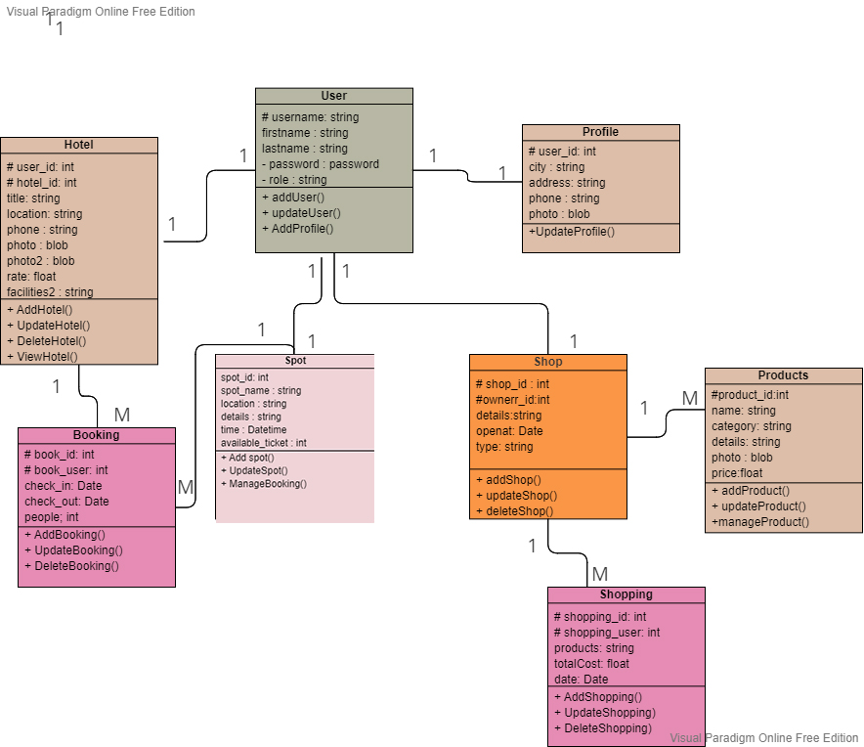

Figure 3.4 Logical data model.

**3.5 Design Requirements**

Design requirements define the critical features of your design that must be met by the customer. This section delves into the details of the web-based system's implementation. The entire application design has been demonstrated in this chapter. The architectural framework of the project, use case diagrams, and ER diagrams are all given. This system will require four different sorts of users, including administrators and users. The project's design is user-friendly, attractive, and well-organized. This project was decorated using cutting-edge design techniques. The program has several advantages and has helped us to plan for future growth. A web-based application allows us to access information from anywhere in the globe. We built our software such that the user, the administrator, may establish an account.

**Chapter: 4**

**Design Specification**

**4.1 Font-end Design**

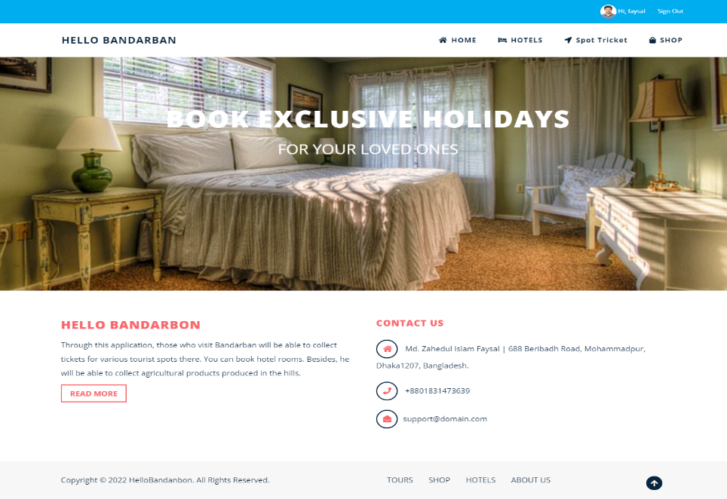Front-end web improvement is the demonstration of changing data over to a graphical point of interaction for clients to see and team up with data through a mechanized association. Front-end configuration is about the UI of the application. Here is the UI plan and connections can see every one of the data in a proficient course of action that is everything except hard to scrutinize and assemble. For arranging front-end improvement HTML, CSS, Bootstrap4, and JavaScript substance were used to make our organization structure.

Figure 4.1.1: Front-end design of home page.

**4.1.1 HTML**

“HTML (HyperText Markup Language) is the coding that organizes a web page's content and structure. Content could be organized using words, a list of bulleted points, or graphics and data tables, for example. This tutorial will teach you a real knowledge of HTML and its abilities, as the title suggests” [7].

**4.1.2 CSS**

“CSS (Cascading Style Sheets) is a stylesheet language for describing the appearance of an HTML or XML content (including XML dialects such as SVG, MathML or XHTML). CSS specifies how elements should appear on a screen, on paper, in voice, or in other forms of media” [7].

**4.1.3 Bootstrap**

“Bootstrap is a free and open-source web improvement structure. It's intended to facilitate the web improvement process of responsive, portable first sites by giving an assortment of grammar to formatting plans” [7].

**4.1.4 Java Script**

“JavaScript is otherwise called JS. It is a unique programming language. Fundamentally it is the programming language of the web for its lightweight. JavaScript gives website pages’ intelligent parts that interface with a client” [7].

**4.2 Back-end Design**

Back-end Design comprises of a worker, an application and an information base. It is simply forming code that isn't seen direct or eye to eye. Backend connected frontend to database and performing all the necessary task. There are many programing languages that is as a backend language for developing software and web applications. The most famous backend programing languages are Java, Ruby, Python, PHP, .Net and so on.

**4.2.1 Python**

“Python is a general-purpose programming language with such an abstract level. It takes a multi-paradigm approach to programming, which means it can handle procedural, object-oriented, and certain functional techniques. Python is a broadly useful language, meaning it tends to be utilized to make a wide range of projects and isn't particular for particular issues” [7].

**4.2.2 Django**

“Django is a server-side web framework built-in Python that is very popular and has a lot of features. This module explains why Django is among the most widely used web frameworks, how to build up the development platform, and how to begin developing your own online applications with it” [7].

**4.2.3 SQL**

“SQL is utilized to speak with a database. As per ANSI, it is the standard language for social database the board frameworks. SQL articulations are utilized to perform assignments like refreshing data on a database or recovering data from a database” [7].

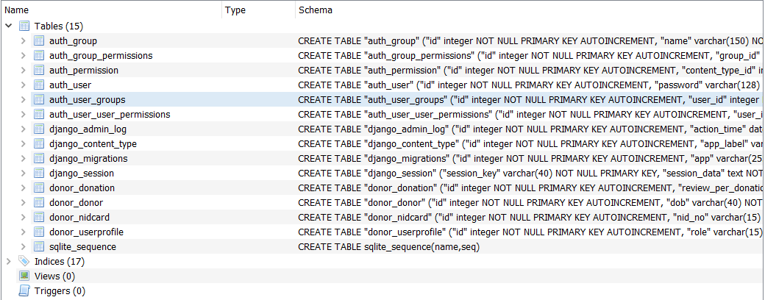

Figure 4.2.3: SQL for database management (migration table).

**4.3 Interaction Design and UX**

We built the web application taking care of bootstrap and text style marvelous. Originators focuses on building enrolling web interfaces with sensible and activities. Entire plan of this project is easy to use and some advanced and update configuration apparatuses have been utilized for this task.

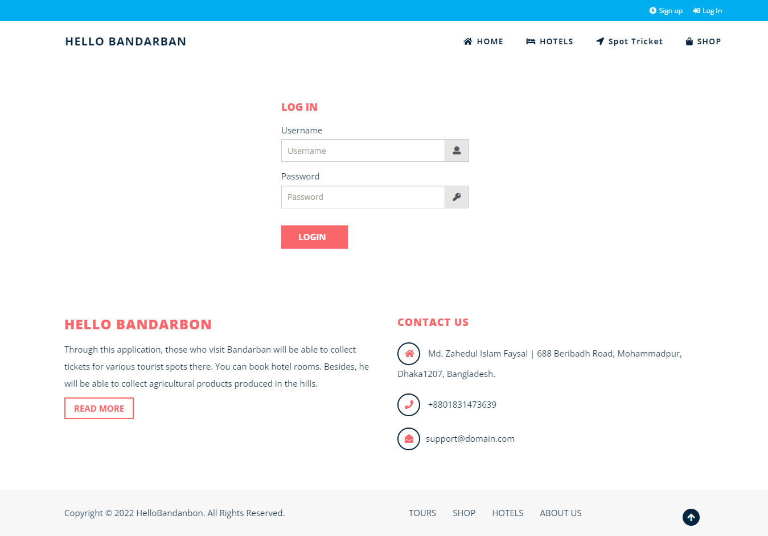

Figure 4.3.1: User profile Empire Knowledge

**4.3 Implementation Requirements**

* The programming language Python.
* For Database SQL.
* Any Code Editor (Visual Studio)
* Minimum 2GB Ram
* Django Virtualenv
* 32bit or 64 bit Operating system with windows 10
* Email Configuration

**Chapter: 5**

**Implementation and Result**

**5.1 Implementation of database**

The application is worried about finding your present information base administration framework on the expected equipment, as well as refreshing the informational index to execute the ideal programming stage. The division of the progress framework into a development of stages, steps, each founded exclusively on a solitary piece of the turn of events, is a fundamental piece of programming development.

Here we have used SQLite database for stoning all the data of our web application. Through our application is simple and small in size so we don’t need any extra advance database. So we have chosen SQLite Database for our project.

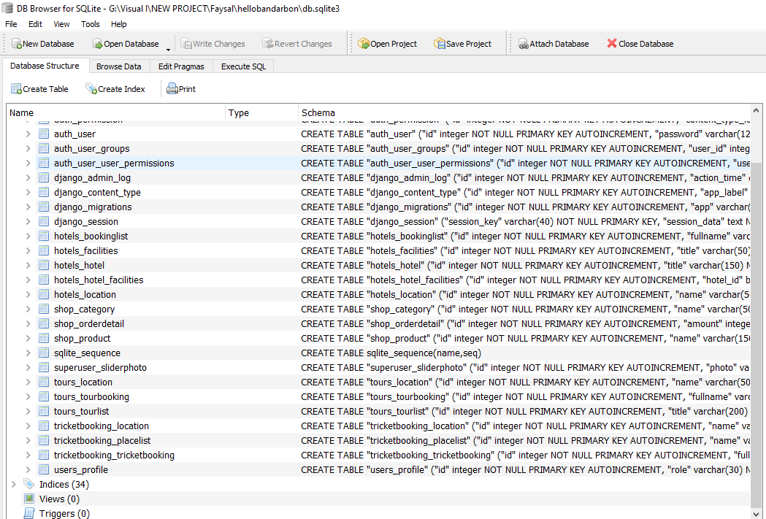

Figure 5.1.1: Implementation of sql database.

This is the implementation of our sql database system. Basically we have created a lot of table to manage our system. For storing user data use have use Django built in data model User table and for Profile management we have created Profile Data Table. For storing hotel information, we have Hotel Table and for booking room we have booking table also. For specify location for hotel we have add another table for location.

We have Product Table, Category Table and Product Booking Table for managing Online shop and users. There also Place List and Location and Booking List Data Table for the Spot ticket management part. We have built different data model for storing data in our data base easily and safely.

**5.2 Implementation and Front-End Design**

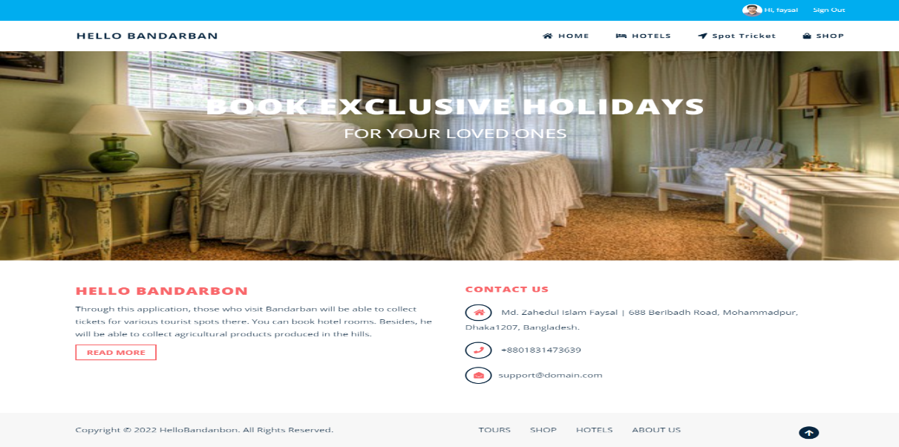Front-end development for the most part called client-side development which was set up of making HTML, CSS, Bootstrap, and JavaScript for a web application. So a client can watch and interface with them expressly. The testing system related with front-end improvement to cause the front finish of a site to change reliably in this manner the originator requests to constantly consider how to field is promoting.Here we are showing the homepage of our web application. We have try to make a user friendly and fully responsive web design for our application and here is a simple of that.

Figure 5.2.1: Home Page

Then comes to Hotel Room page where user will find all kind of room with all ranges. There is an overview for the user that is some details of that room, room rent, how many people already booked it, room type etc. There is a image of that room so that user can easily see that room which they want to booked.

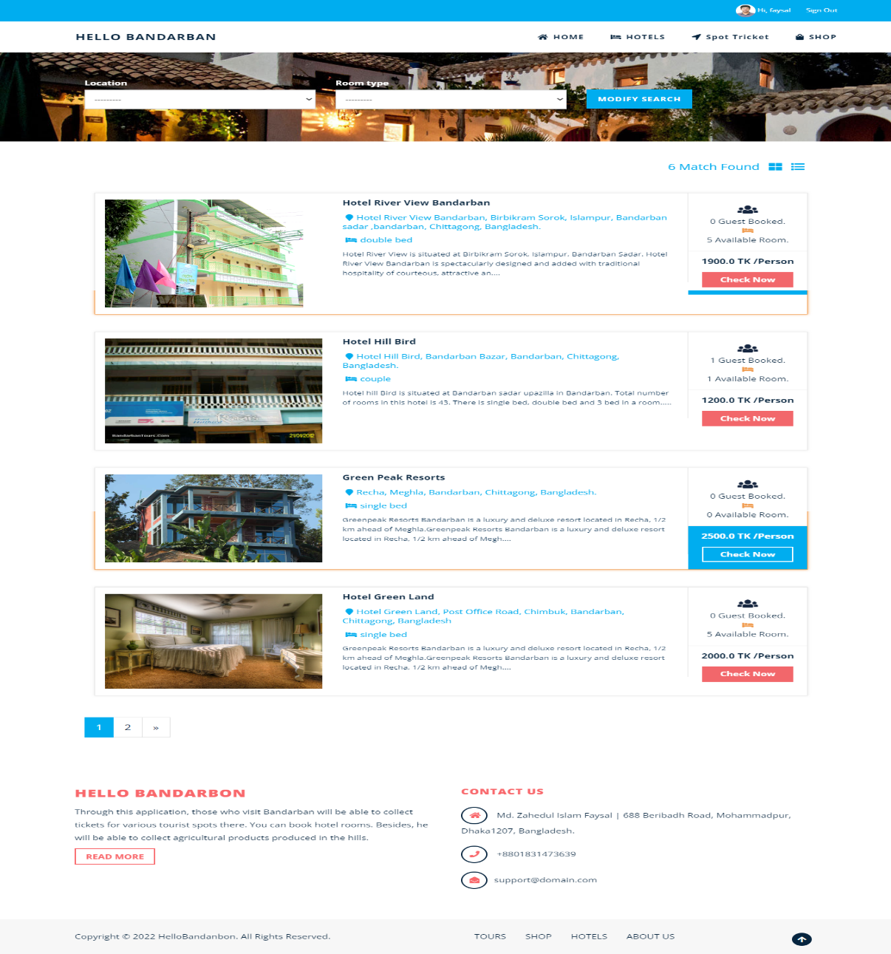

Figure 5.2.2: Hotel Room Page

There is also search and filter features for the user. If any user wants to filter the room he can do that. We have added Room type and hotel location for filtering the data.

After searching hotel rooms need to check out the room for more details. And These room can be booked by only the regular user of our website. No hotel can owner can have reserved or booked any hotel rooms.

Now come to details page of Hotel room. If any user wants to see the details of any hotel rooms then he can check out this. Here we can get know more about that hotel room. We may also know hotel exact location, Hotel owner phone number, no of available rooms, total room booked. We can know more details and other facilities included in this rooms services.

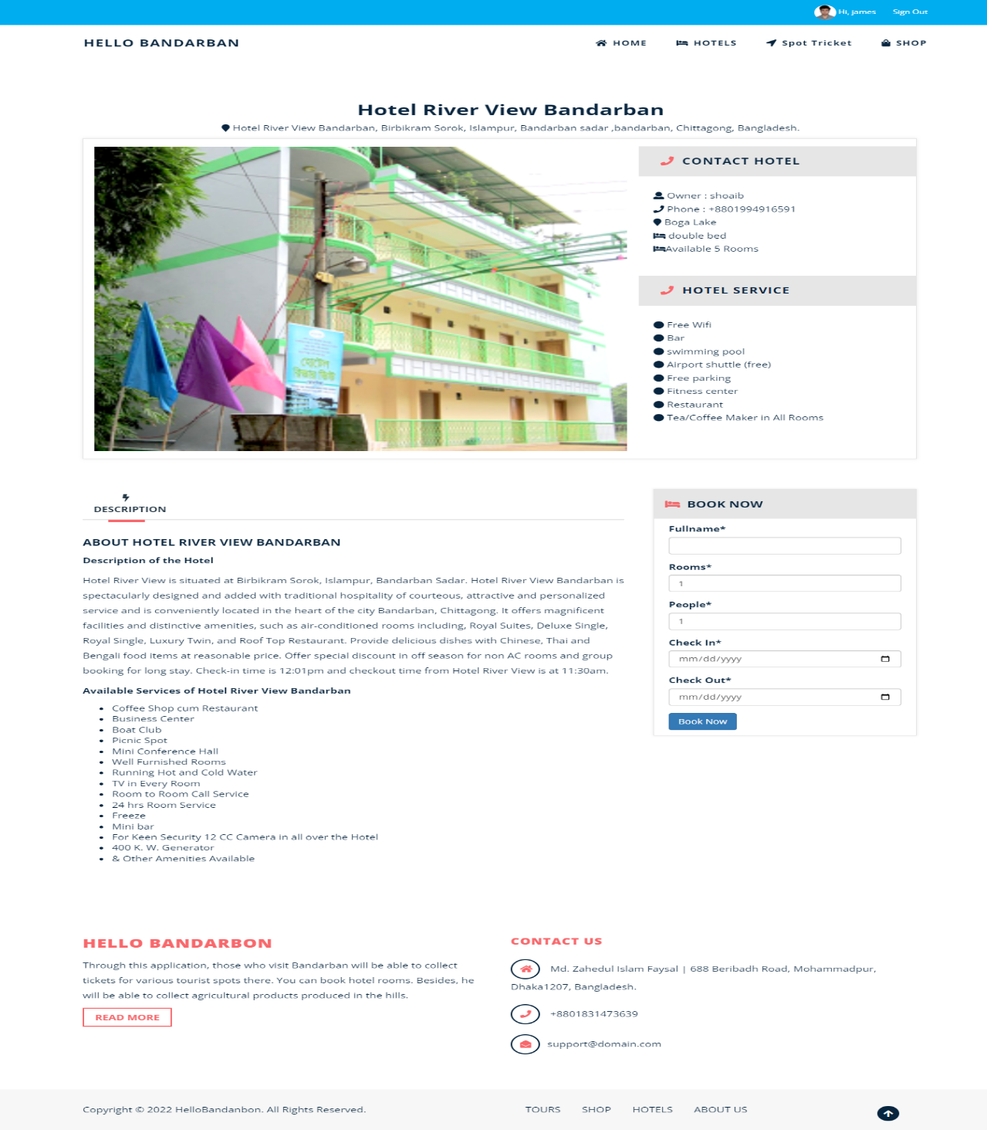

Figure 5.2.3: Hotel Details Page

Only regular user can have booked hotel rooms. He need to just write his full name, select total number of room he wants to booked, Total people and finally check in and check out date Then send request for booking approval. If hotel owner accepts the booking, then user will get notification for booking confirmation

Another part of our website “Hello Bandarban” is tour spot and ticket booking. Actually peoples wants to go out for a long to to visis some interesting places. So they need to buy tricket, we have make a plart form for those kind of people who want to visit any tourist spot and booked those palces. Here we can see the spot bokking home page.

There is a list of spot places and some infor with it. User can also search and filter the spot by using spot name and location with time.

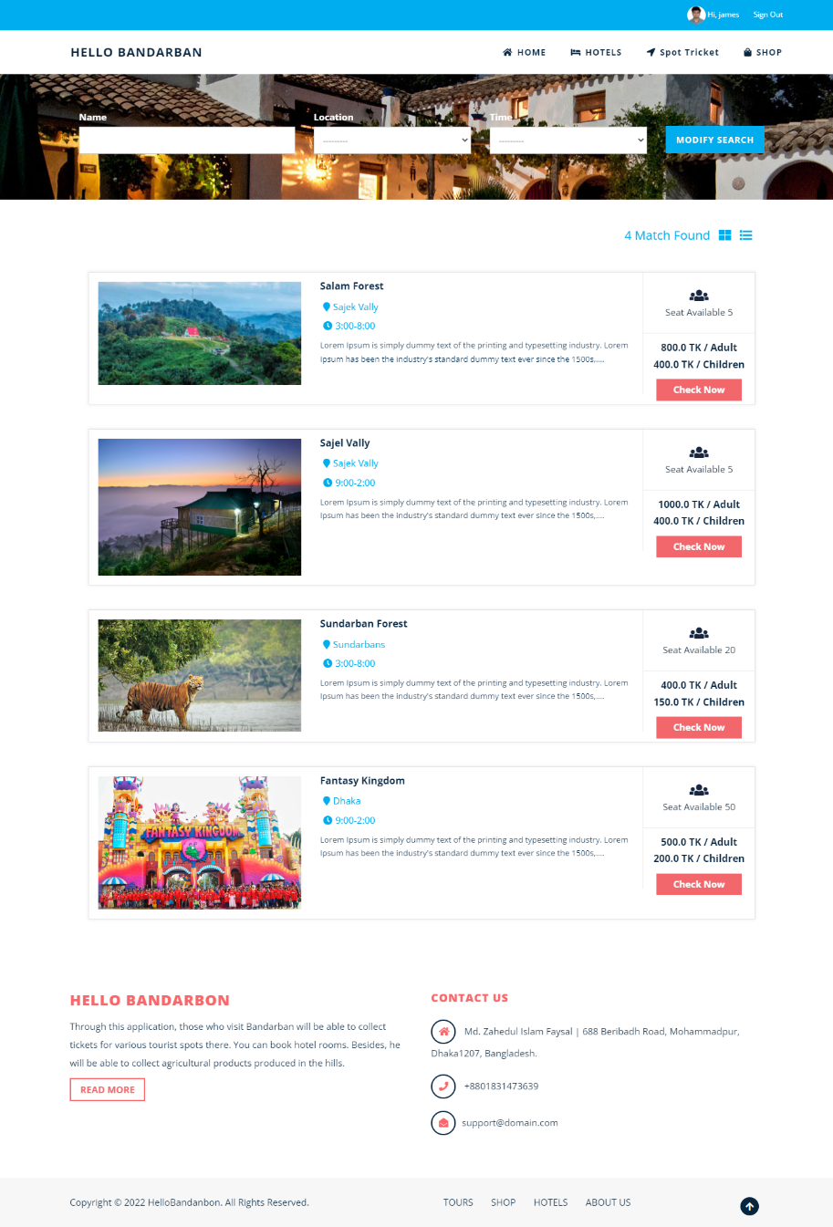

Figure 5.2.4: Tour Spot Home Page

Only regular user can book ticket of those tourist spot. User can learn more details of that tourist spot just click on check now button. By this page user may get information like spot location, available time, available seat, per seat price both for adult and children.

Now this is Spot details page where user can knoe more about the spot and ticket. User can know about the spot owener and his contact number, exact location of that spot, ticket price both for adult and children rate. Spot details describe here fully details mode so that user can know depply about this spot and try to book ticket.

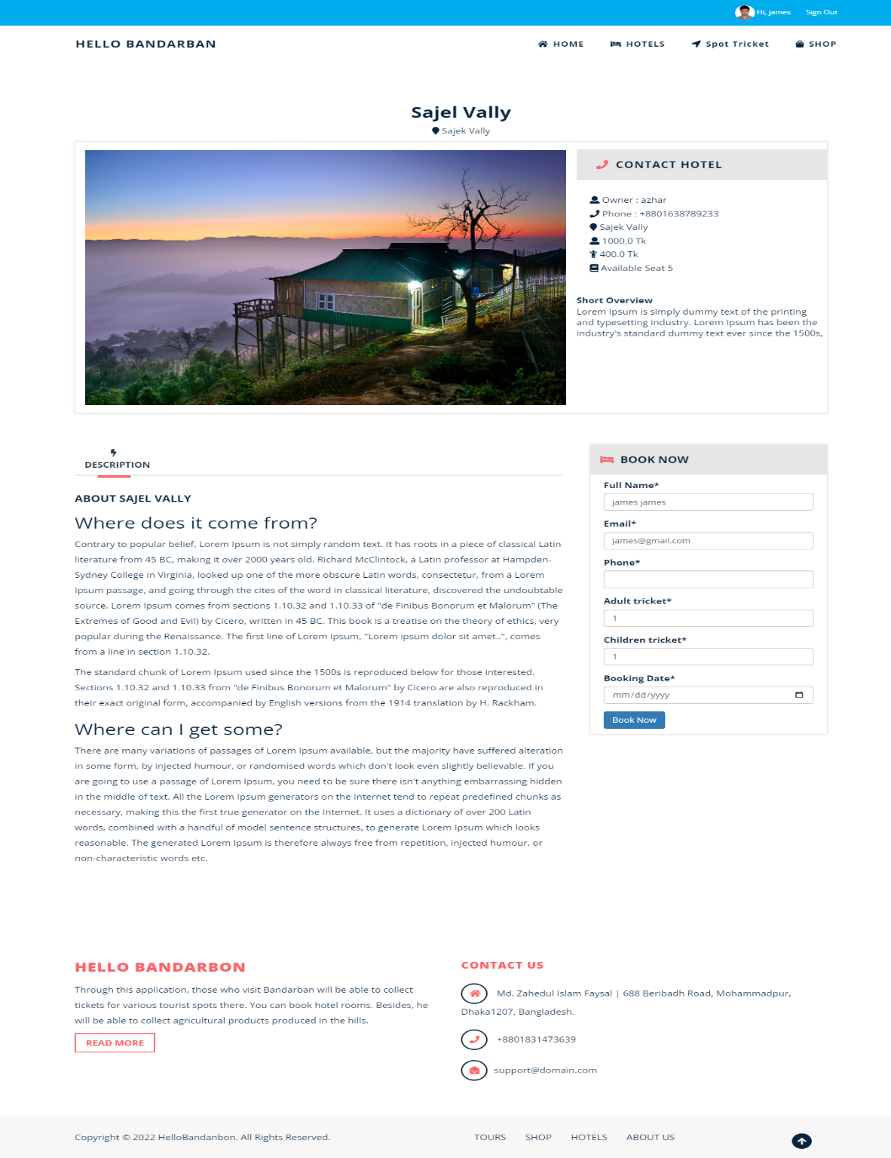

Figure 5.2.5: Spot details page

If any user likes this spot and try to make some booking he or she can easily make a booking. We have added a booking form here. User just need to fill up the form with the necessary information and send booking request. If the spot owner accepts his request, then booking will be confirm otherwise booking will be remain pending. If spot owner reject booking the booking request will be cancel.

We have added another important section in our web application which is online product booking facilities. In this sop section we have added a lot of daily necessary products so that user can book those products for them easily.

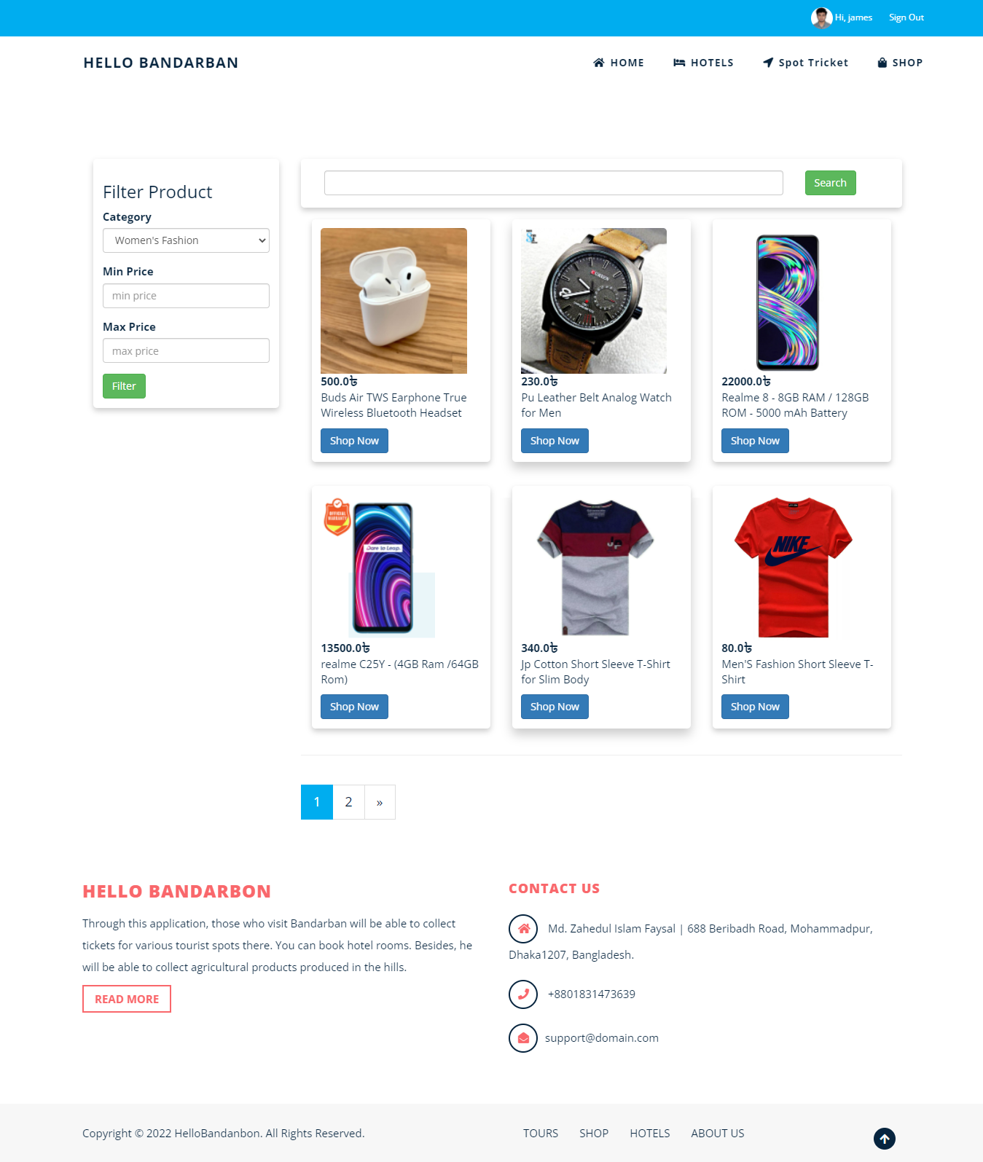

Figure 5.2.6: Shop home page

User can manually search and filter any kind of product that need to them. User can search with the product name, price, category and price range. All the product is arranging in a beautiful way.

In product details page user can see the full details of that poroduct.product name which category it belongs the price and shor description also added here.

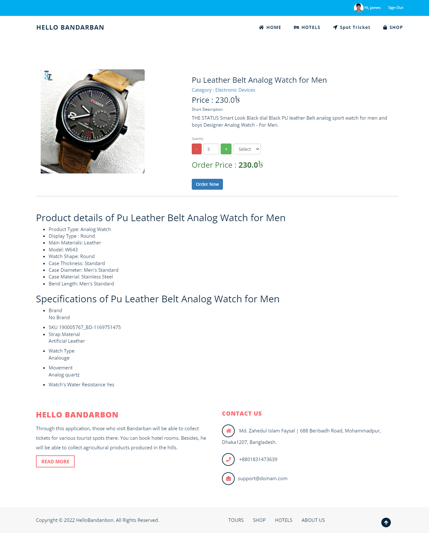

Figure 5.2.7: Product Details

If any user like to buy this product, then he can easily have booked that product for him. For purchasing this product that user just need to select the product quantity and weight then press order button. The product will be booked with that specific user who is login that time. Then the booking request will be sent to product owner and if he accepts the booking request then order will be confirming and if shop owner reject the request then order will be cancel.

We have four kind of user in our web application. Shop owner mange his product in shop page, Hotel owner manage room, spot owner manage spot ticket and regular user booked all the services from these sellers. So we have design 4 dashboard for 4 users with the same design. User facilities change dynamically with the user role.

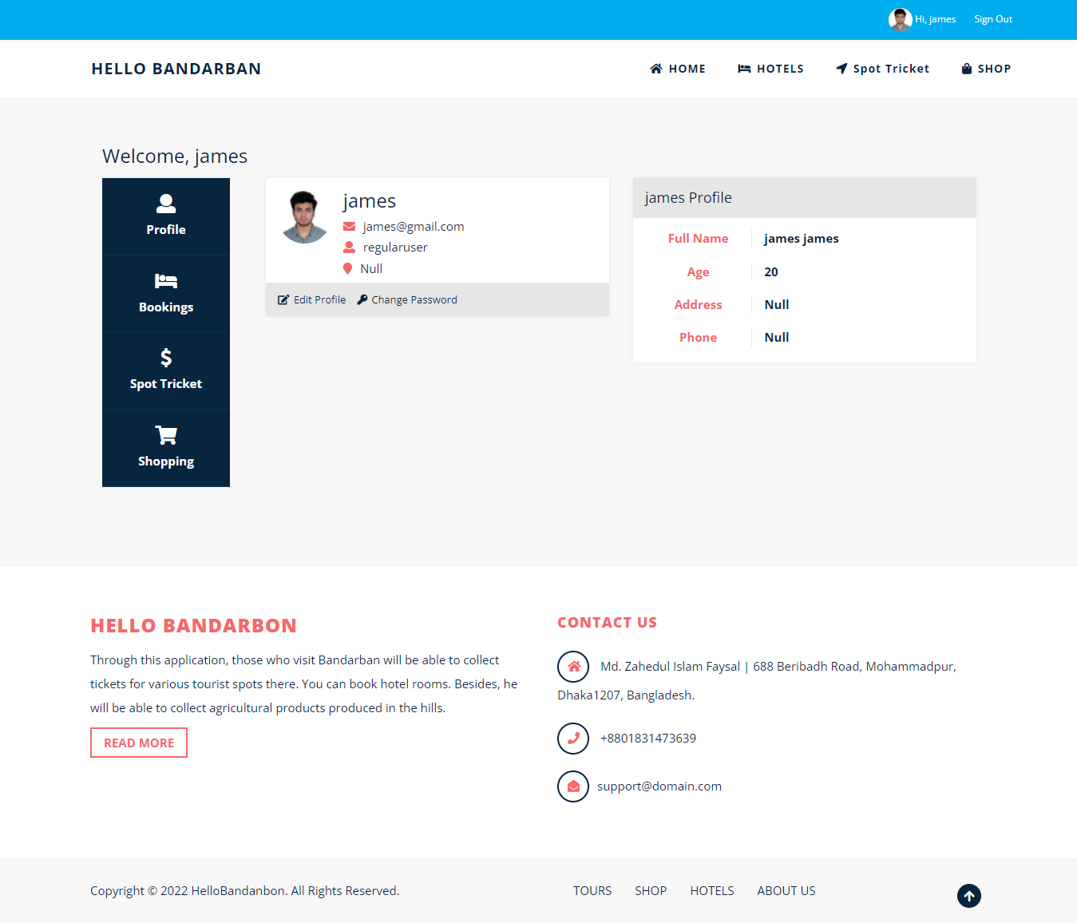

Figure 5.2.8: Dashboard page

Here we can see some features for that user like edit profile, change password, hotel booking list, spot ticket booking list and product booking list.

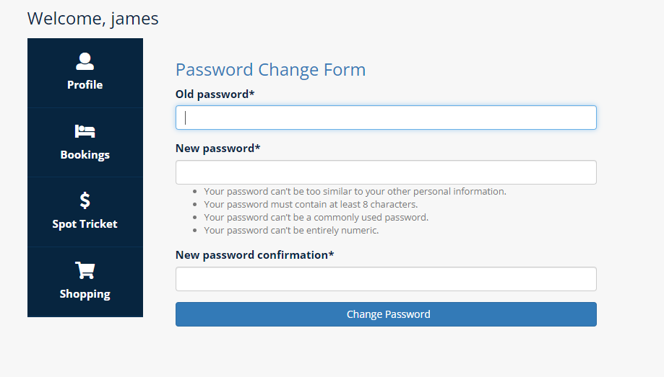

Figure 5.2.9: Change Password page

If user wish to change his or her password, then they can easily perform this task. Sometime for security purpose user need to change his or her password.

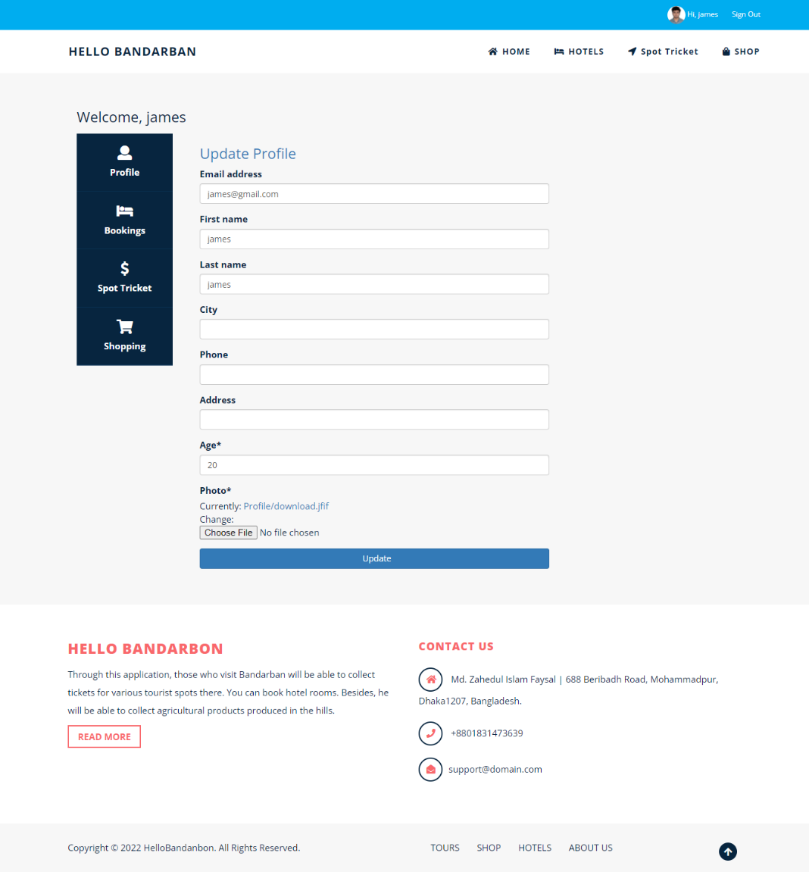

Figure 5.2.10: Edit Profile page

User can change his profile anytime.at the time of registration we take a little bit information from the user but if any user wants to user our services then they need to completed their profile.

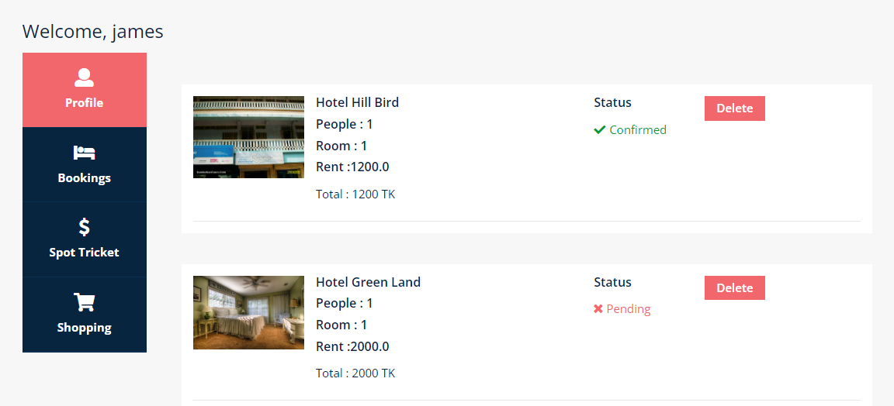

Figure 5.2.11: Hotel booking list

Here we can see the hotel booking list that the user made for himself. We can see the booking status here. Does hotel owner accept the booking request or it still pending. User can also cancel his booking from here.

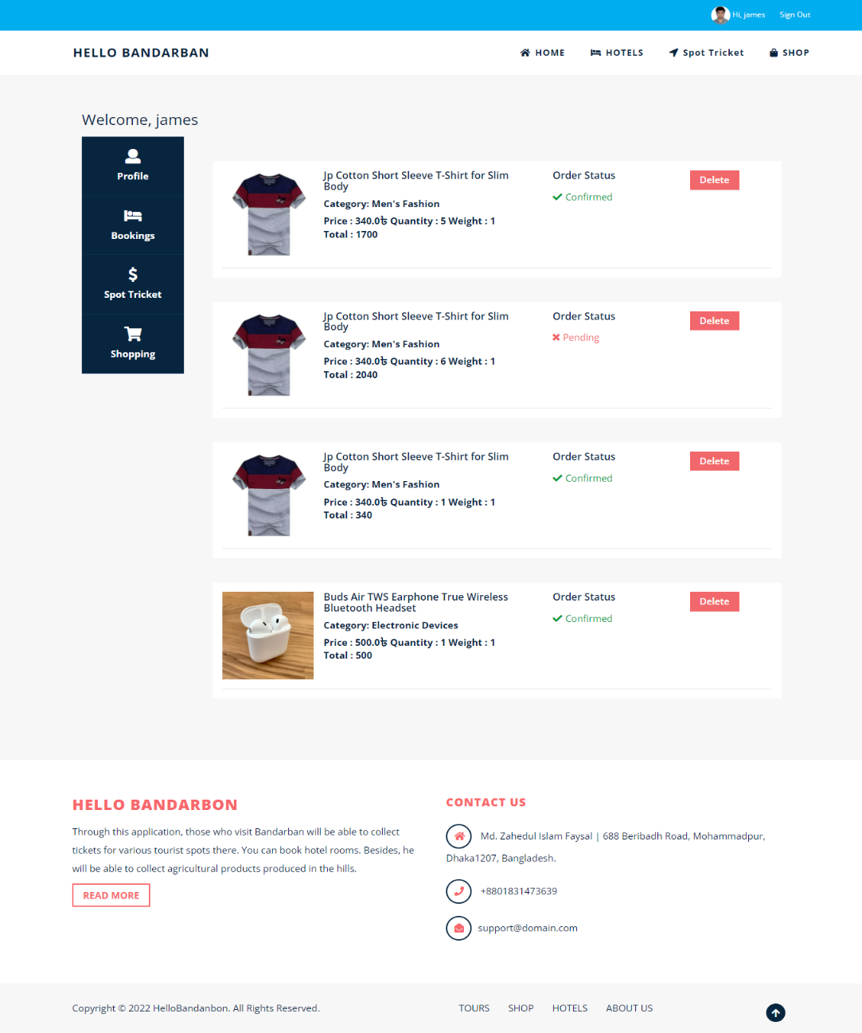

Figure 5.2.12: Product booking list

Here we can see the product booking list that the user made for himself. We can see the booking status here. Does shop owner accept the booking request or it still pending. User can also cancel his booking from here.

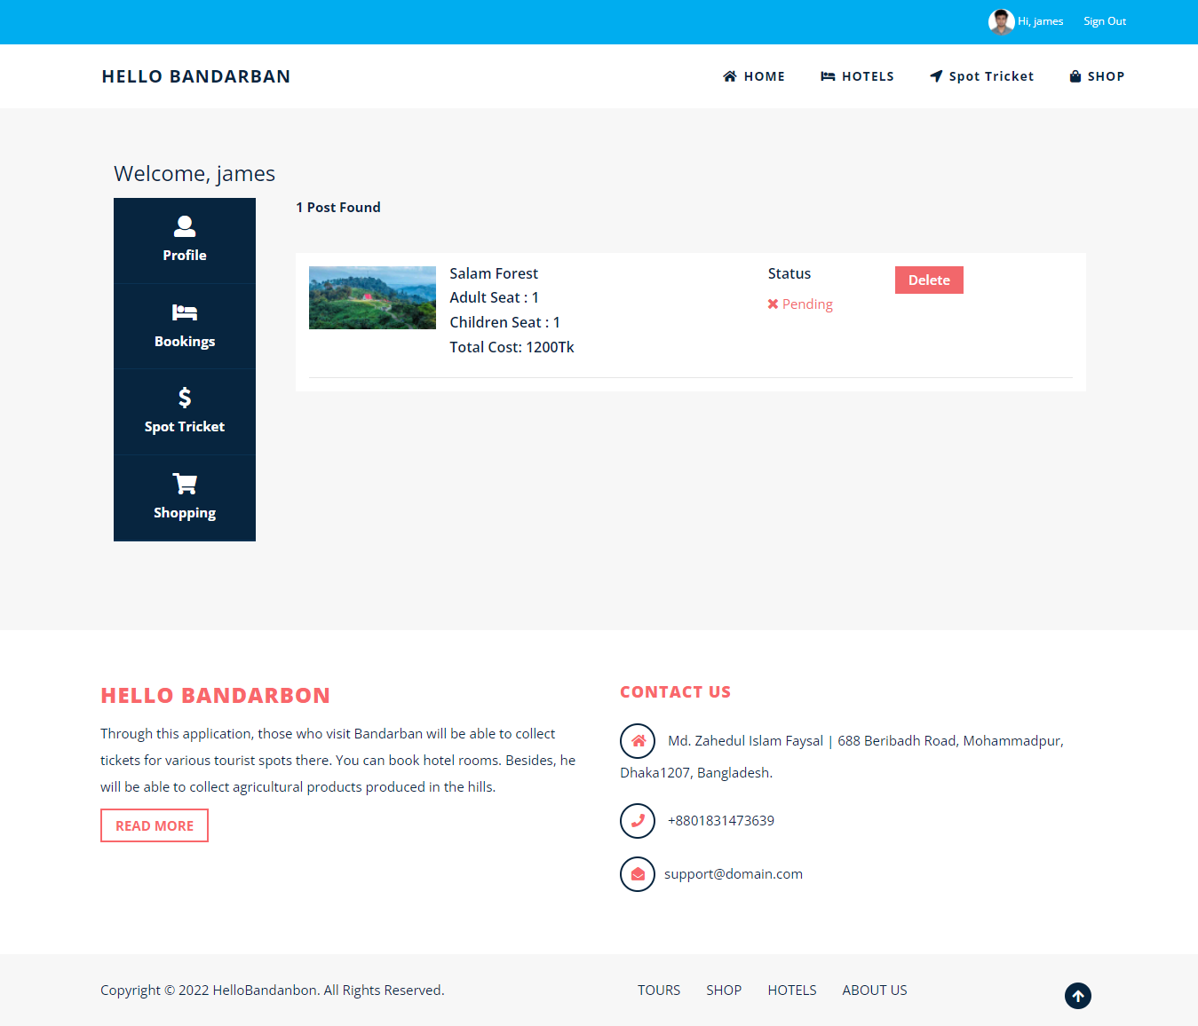

Figure 5.2.13: Spot ticket booking list

Here we can see the spot ticket booking list that the user made for himself. We can see the booking status here. Does spot owner accept the booking request or it still pending. User can also cancel his booking from here.

In shop owner dashboard we have added all the features for the shop owner so that they can manage their product and product booking request.

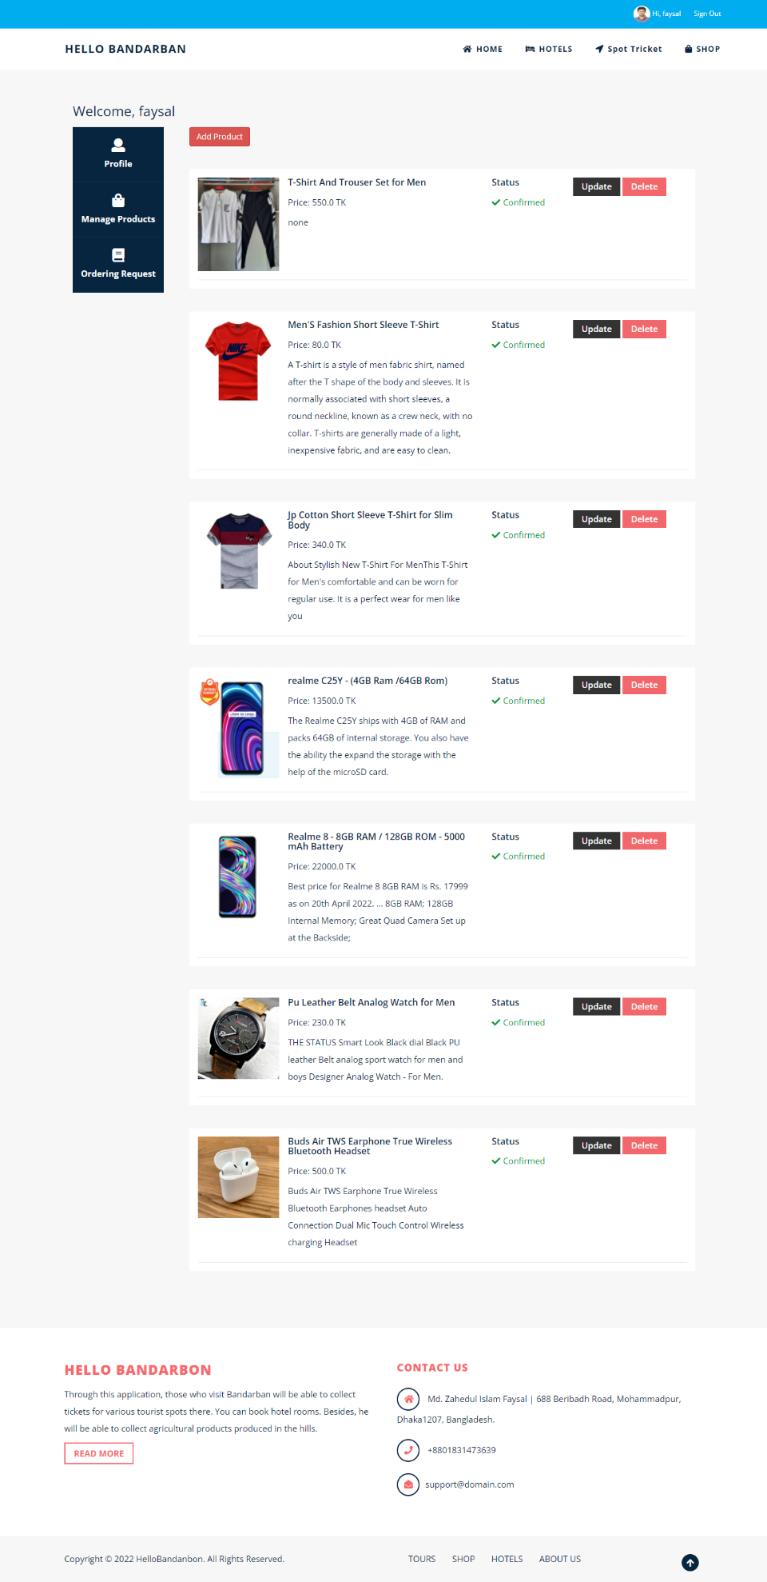

Figure 5.2.14: product list

There is another option for managing product booking request. Shop owner can accept or cancel the booking request.

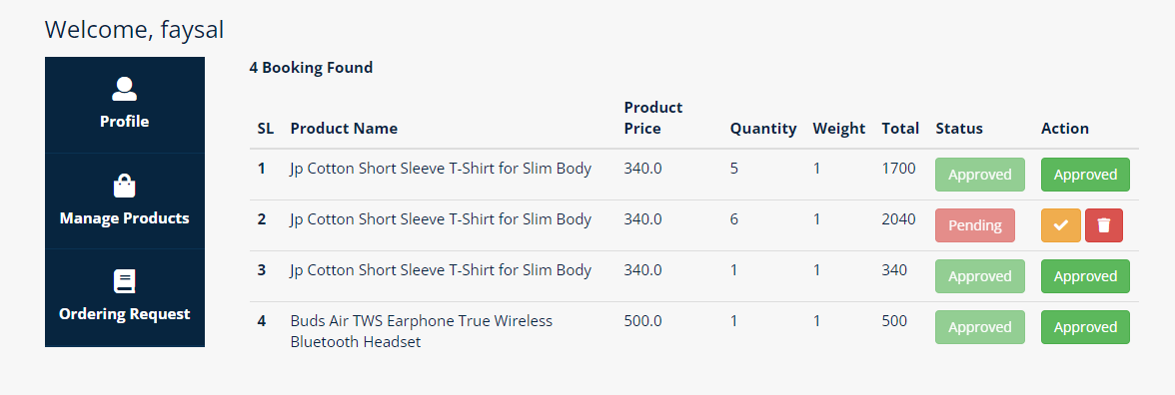

Figure 5.2.15: product booking request list

In Spot owner dashboard we have added all the features for the spot owner so that they can manage their spot post and spot ticket booking request.

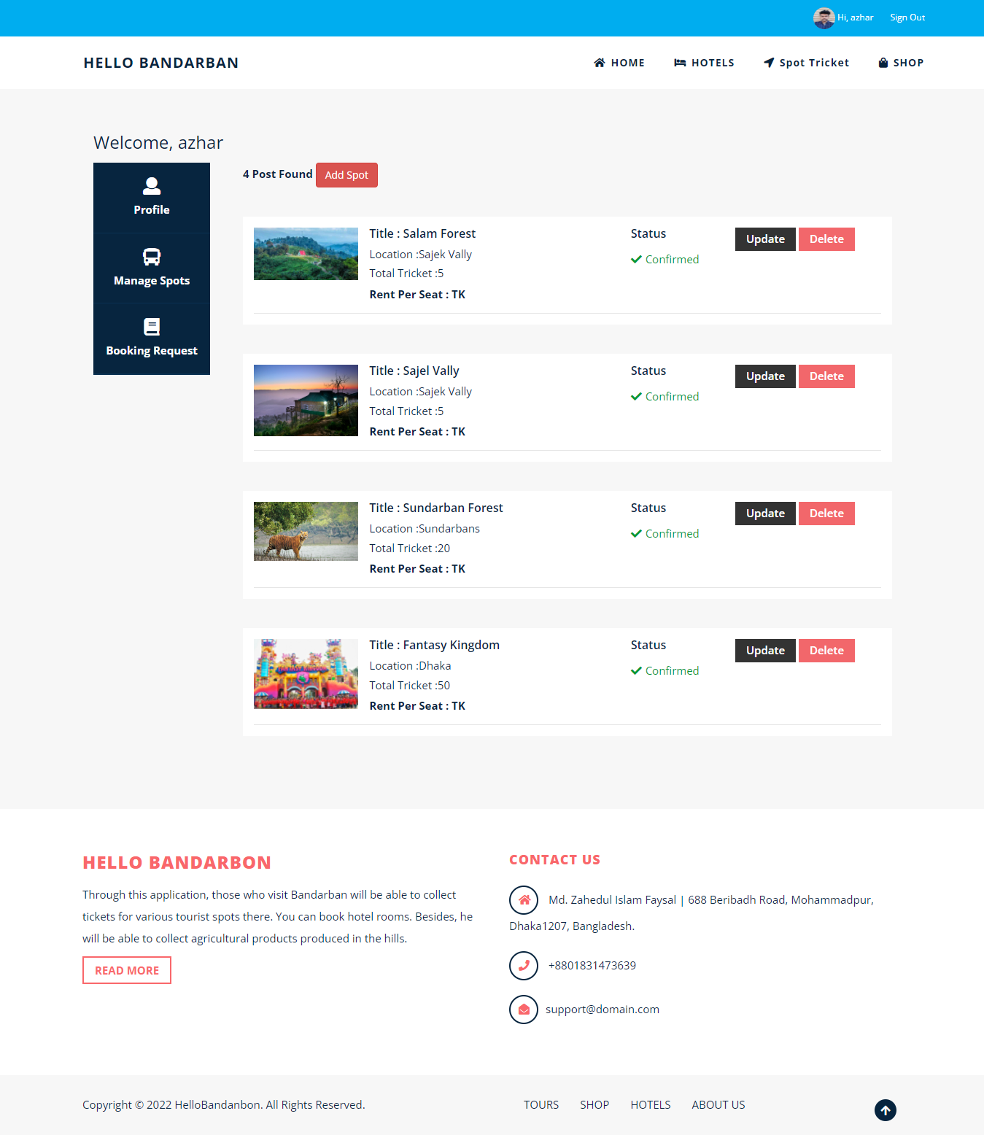

Figure 5.2.16: Spot list

There is another option for managing spot ticket booking request. Spot owner can accept or cancel the ticket booking request.

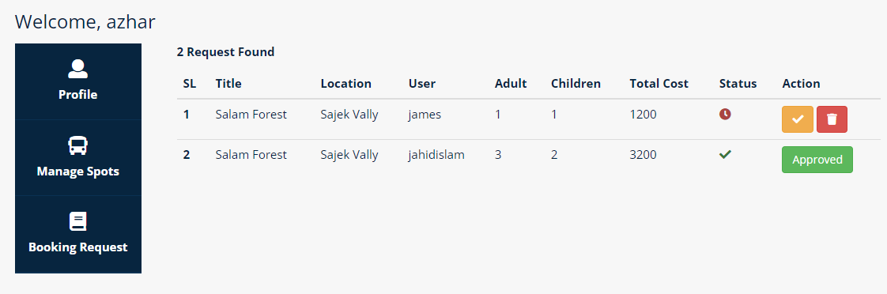

Figure 5.2.17: Spot ticket booking request list

At last Hotel owner dashboard, we have added all the features for the hotel owner so that they can manage their hotel rooms and room booking request.

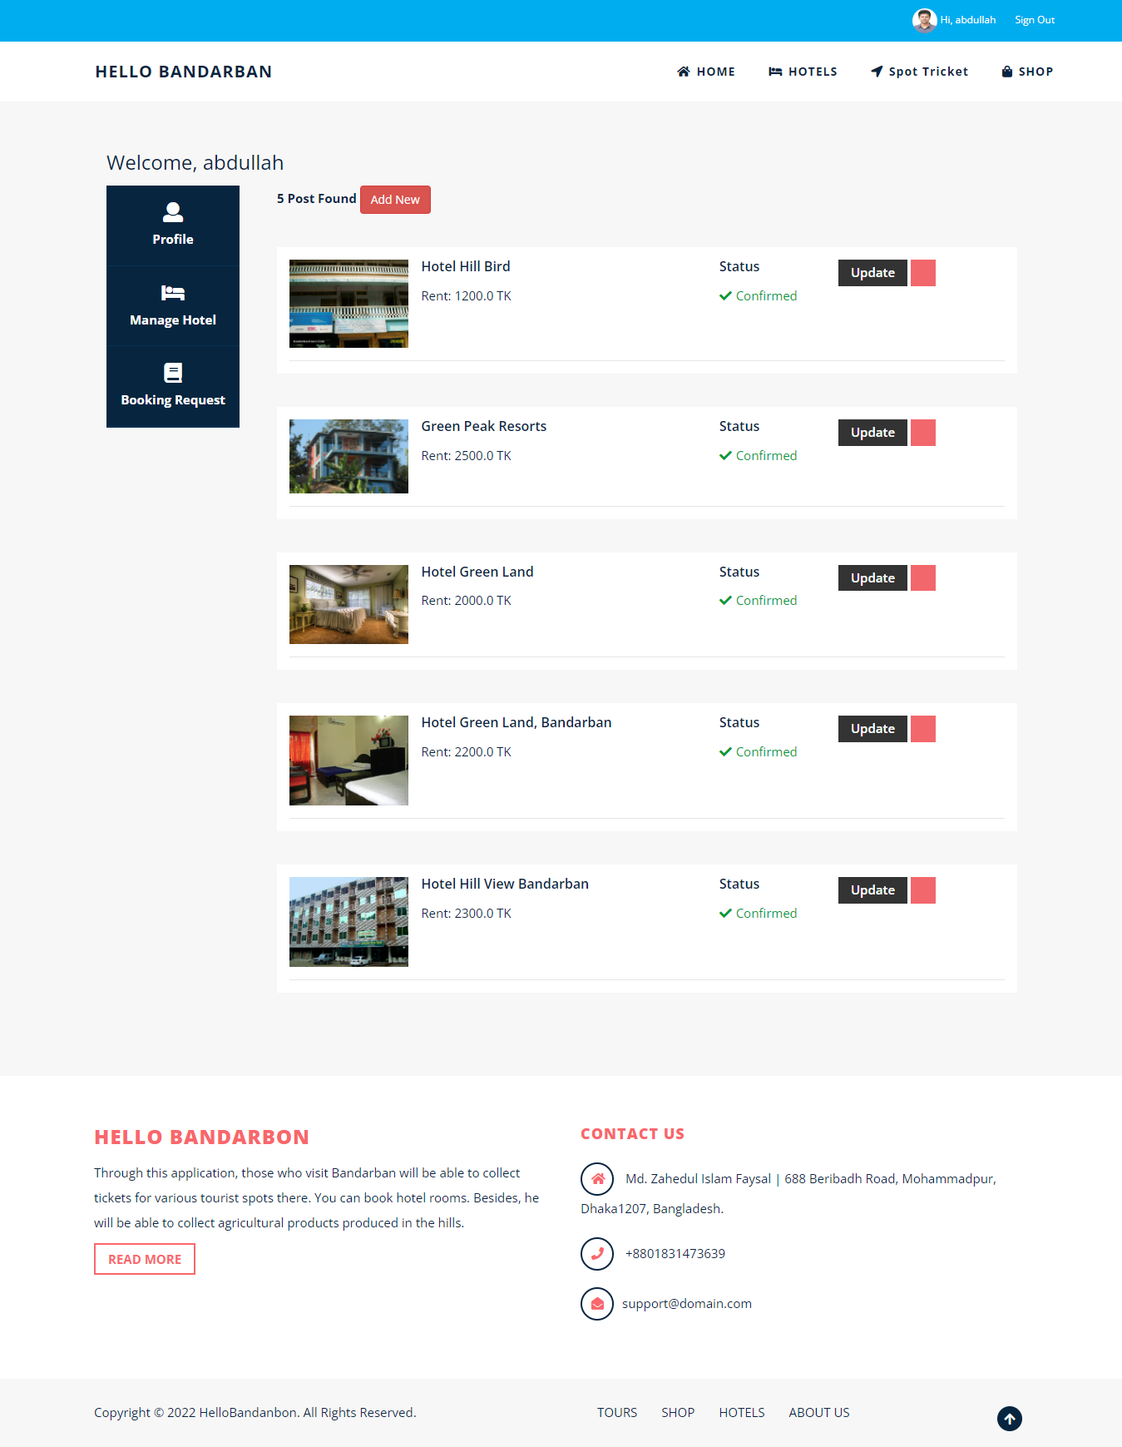

Figure 5.2.18: Hotel list

There is another option for managing hotel rooms booking request. Hotel owner can accept or cancel the room booking request.

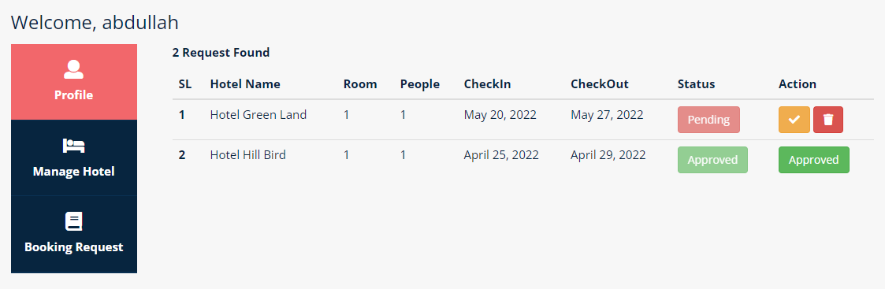

Figure 5.2.19: Hotel room booking request list

**5.3 Testing Implementation**

Software Testing is a strategy to check whether the authentic software thing orchestrates with anticipated necessities and to guarantee that the software thing is without disfigurement. It joins execution of software/framework parts utilizing manual or robotized contraptions to assess no short of what one properties of premium. The defense for software testing is to perceive goofs, openings, or missing prerequisites as opposed to confirmed necessities.

**Functionality Testing:** “Functionality Testing of a Website is a process that includes several testing parameters like user interface, APIs, database testing, security testing, client and server testing and basic website functionalities. Functional testing is very convenient and it allows users to perform both manual and automated testing. It is performed to test the functionalities of each feature on the website” [11].

**Usability Testing: “**Usability Testing has now become a vital part of any web based project. It can be carried out by testers like you or a small focus group similar to the target audience of the web application” [11]

**Database Testing:** “Database is one critical component of your web application and stress must be laid to test it thoroughly. Testing activities will include” [11].

**Performance Testing: “**Website application response times at different connection speeds Load test your web application to determine its behavior under normal and peak loads Stress test your web site to determine its break point when pushed to beyond normal loads at peak time. Test if a crash occurs due to peak load, how does the site recover from such an event Make sure optimization techniques like zip compression, browser and server side cache enabled to reduce load times” [11].

**Security Testing:** “Security Testing is vital for e-commerce website that store sensitive customer information like credit cards. Testing Activities will include” [11]

**5.3 Testing Result and Report**

Unit Testing:1

Data Source: User Entry

Test Class: Basic Functionality

Test Case: 1.1 Login Form

Task: username(“faysal”) & password (12345678)

Expected Result: User Will Fail to Login

Actual Result: Login Fail

Test Case: 1.2 Login Form

Task: username(“faysal”) & password (171-15-9228)

Expected Result: User Will Successfully to Login

Actual Result: Login Success

Integration Testing:

Unit Testing:1

Data Source: User Entry

Test Class: Basic Functionality

Test Case: 1.1 Password Change Form

Task: old password(“false”), new password(“true”), confirm password(“true”)

Expected Result: User will fail to change password

Actual Result: password change fail

Test Case: 1.2 Password Change Form

Task: old password(“true”), new password(“true”), confirm password(“true”)

Expected Result: User will success to change password

Actual Result: password change successes

**Chapter: 6**

**Impact on Society, Environment and Sustainability**

**6.1 Impact on Society**

In the digital era, every human emotion can be related to the texts we see on a daily basis on numerous internet platforms. In which motion, it is fundamental for these platforms to have a system to determine which are actual emotions and which are aggression placed. This is why we have decided to draw our work towards detecting one of the most interesting genres of all time, known as Humor. By this kind of work, in hope to build a more conclusive and variance free internet era.

**6.2 Impact on Environment**

Across many internet platforms now a day it is very common in sharing a social or political matter using a very conclusive term of humor mixed mocking. But with humor it is possible to represent a social perspective on terms in various topics. Which and why we should be more careful toward the technological conclusiveness, so that the frameworks are fully capable to understand which is which. Because there is a numerous report of people to be able to understand many environmental defects by using the humor as for the main orthodox. So detecting humor can be proven to be both beneficial to peoples perspective on the environment around them.

**6.3 Ethical Aspects**

The social media platforms across the internet now have become available to all kind of age users. So the terms of user restrictions are out of check. Because there cannot be enough kind of security measurements to determine between the moral and social perspective. One needs to be able to understand the main context behind a concept represented via the platforms. In many cases this could be proven to harm towards people moral values. Without understanding proper humor, the algorithm could ban an actual message while approving a hurtful message.

**6.4 Sustainability**

* There are generally speaking 2.3 billion overall dynamic internet-based life clients.
* 91% of huge corporate brands have at least two internet-based life stages.
* 65% of all people feel awkward and uncomfortable when they can't access their online life profiles.

**Chapter: 7**

**Conclusion and Future Work**

**7.1 Discussion and Conclusion**

This task has offered me more than an adequate chance to configure, code, test, and carry out an application. This has helped in incorporating different Software Engineering standards and Database Management ideas like keeping up with respectability and consistency of information. A greater part of the benefactors was able to be standard givers. The contributors showed constructive outcomes like a feeling of fulfillment after the gift. Setting out a freedom for blood gift by directing many blood gift camps might increment willful blood gifts.

**7.2 Limitation**

Despite the fact that I have invested my best amounts of energy to make the product adaptable, simple to work yet limits can't be precluded even by me. However, the product presents an expansive scope of choices to its clients some perplexing choices couldn't be covered into it; somewhat as a result of coordination’s and mostly because of absence of complexity. The scarcity of time was likewise a significant requirement, accordingly it was impractical to make the product idiot proof and dynamic. We have only managed booking part only but there is no payment and delivery features in our system. There no any validation of hotel and shop identity except Email verification.

List of limitations which is available in Hello Bandarban:

* Don’t use Govt Nid server for validating user Identity.
* Communication system is not well functional.
* No Payment System.
* No track Booking Process.
* No Delivery Process.

**7.3 Scope for Further Developments**

Basically, it tends to be summed up that the future extent of the venture circles around keeping up with data in regards to:

* We can add online chatting system.
* Add Online payment system.
* Track Booking
* Validation of Hotel owner, Shop owner, Spot owner.
* We can convert web app to mobile application.
* We will have the stage on internet based servers to make it open around the world
* Advertising for our application.
* We will have the stage on internet-based servers to make it open overall
* Integrate various burden balancers to disperse the heaps of the framework
* Create the expert and slave information base design to decrease the over-burden of the data set inquiries

**REFERENCES**

[1]. <https://www.w3schools.com/>

[2] <https://docs.python.org/3/>

[4]. <https://www.youtube.com>

[5]. <https://docs.djangoproject.com/en/3.1/>

[6]. <https://digitalcommunications.wp.st-andrews.ac.uk/2020/03/30/website-performance-and-the-hidden-environmental-impact-of-the-internet/>

[7]. <https://developer.mozilla.or>

[8]. https://www.londontfe.com/blog/3-reasons-why-finance-is-an-essential-part-of-project-management

[9] <https://www.freeprojectz.com/project-report/6124>

[10] https://www.freeprojectz.com/project-report/3430

[11] https://www.guru99.com/web-application-testing.html